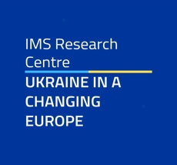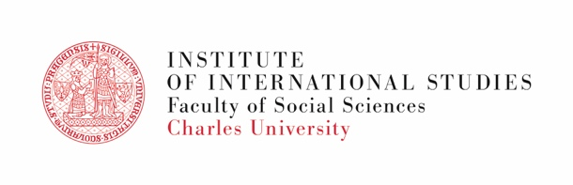
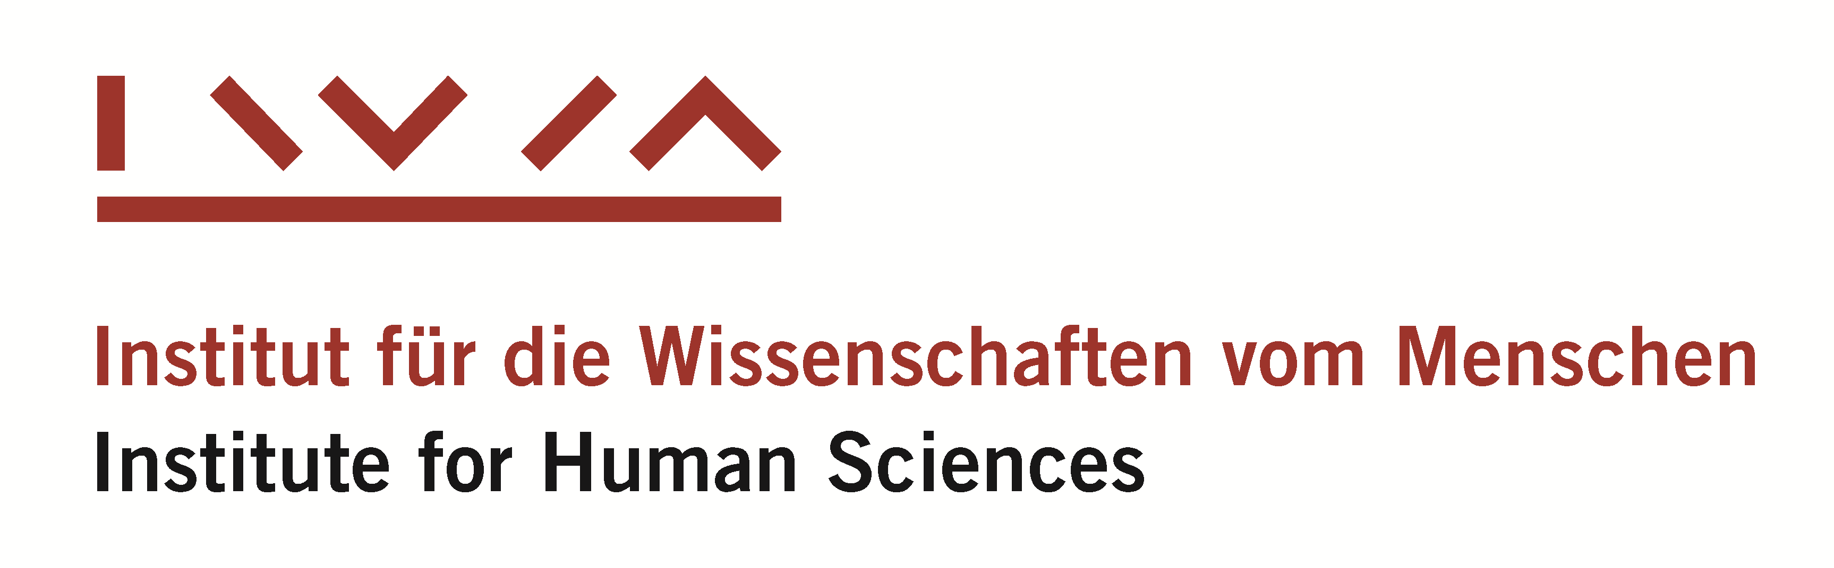

IWM-IMS Joint Fellowship 2025

Ukraine and a Changing World Order

APPLICATION FORM
Please return your complete application materials to
valeriya.korablyova@fsv.cuni.cz and ukrainianstudies.ims@fsv.cuni.cz
Head of the Research Centre “Ukraine in a Changing Europe”
Institute of International Studies, Charles University
Subject header: IWM-IMS Fellowship
Deadline: 15 March 2025

APPLICANT
Family name |  | First name
Female □
Male □
Other □
Nationality | Date of birth |  | Gender

TITLE OF PROPOSED RESEARCH PROJECT

ABSTRACT OF PROPOSED RESEARCH PROJECT
Max 100 words

EDUCATION
Academic degree(s) | University, city, country | Date

PROFESSIONAL AFFILIATION
Name of institution
Position
From date

APPLICATION INFO
Expected start date of scholarship (dd/mm/yyyy)
End date (dd/mm/yyyy)
Date of submission:

CONTACT DETAILS
Street, No. | City, zip code
E-mail | Phone

Checklist
□ Application Form
□ Abstract
□ Project Proposal
□ CV + Publication List
□ Cover Letter (writing & teaching activities)
□ Two Recommendation Letters

